CREATE & CONFIGURE IBM CLOUD SERVICE CREATE THE TEXT-TO-SPEECH SERVICE

|  |  |
| --- | --- |
| Team ID | PNT2022TMID10261 |
| Project Name | Personal Assistant for senior people who are self reliant |

Installation of Watson-TTS Client library Provided for Python: Code:

Pip install -upgrade”ibm-watson>=6.1.0”

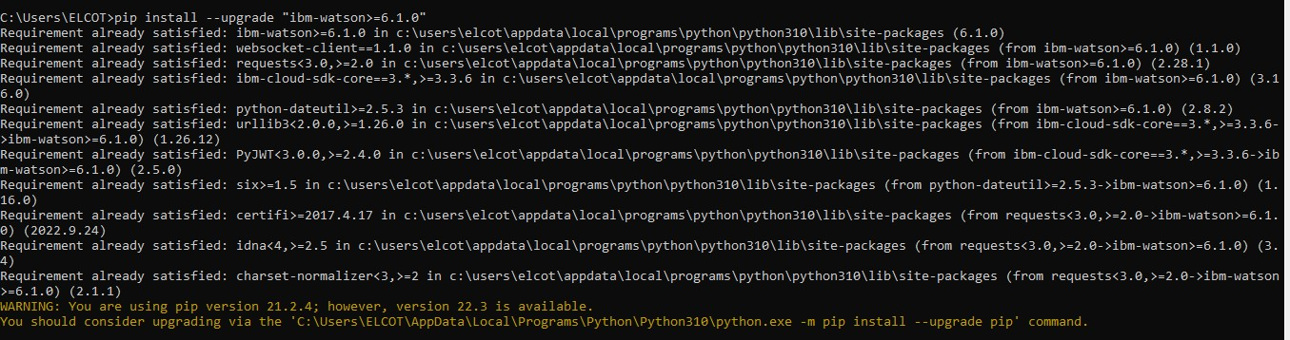

Service Creation Status & Credential Details:

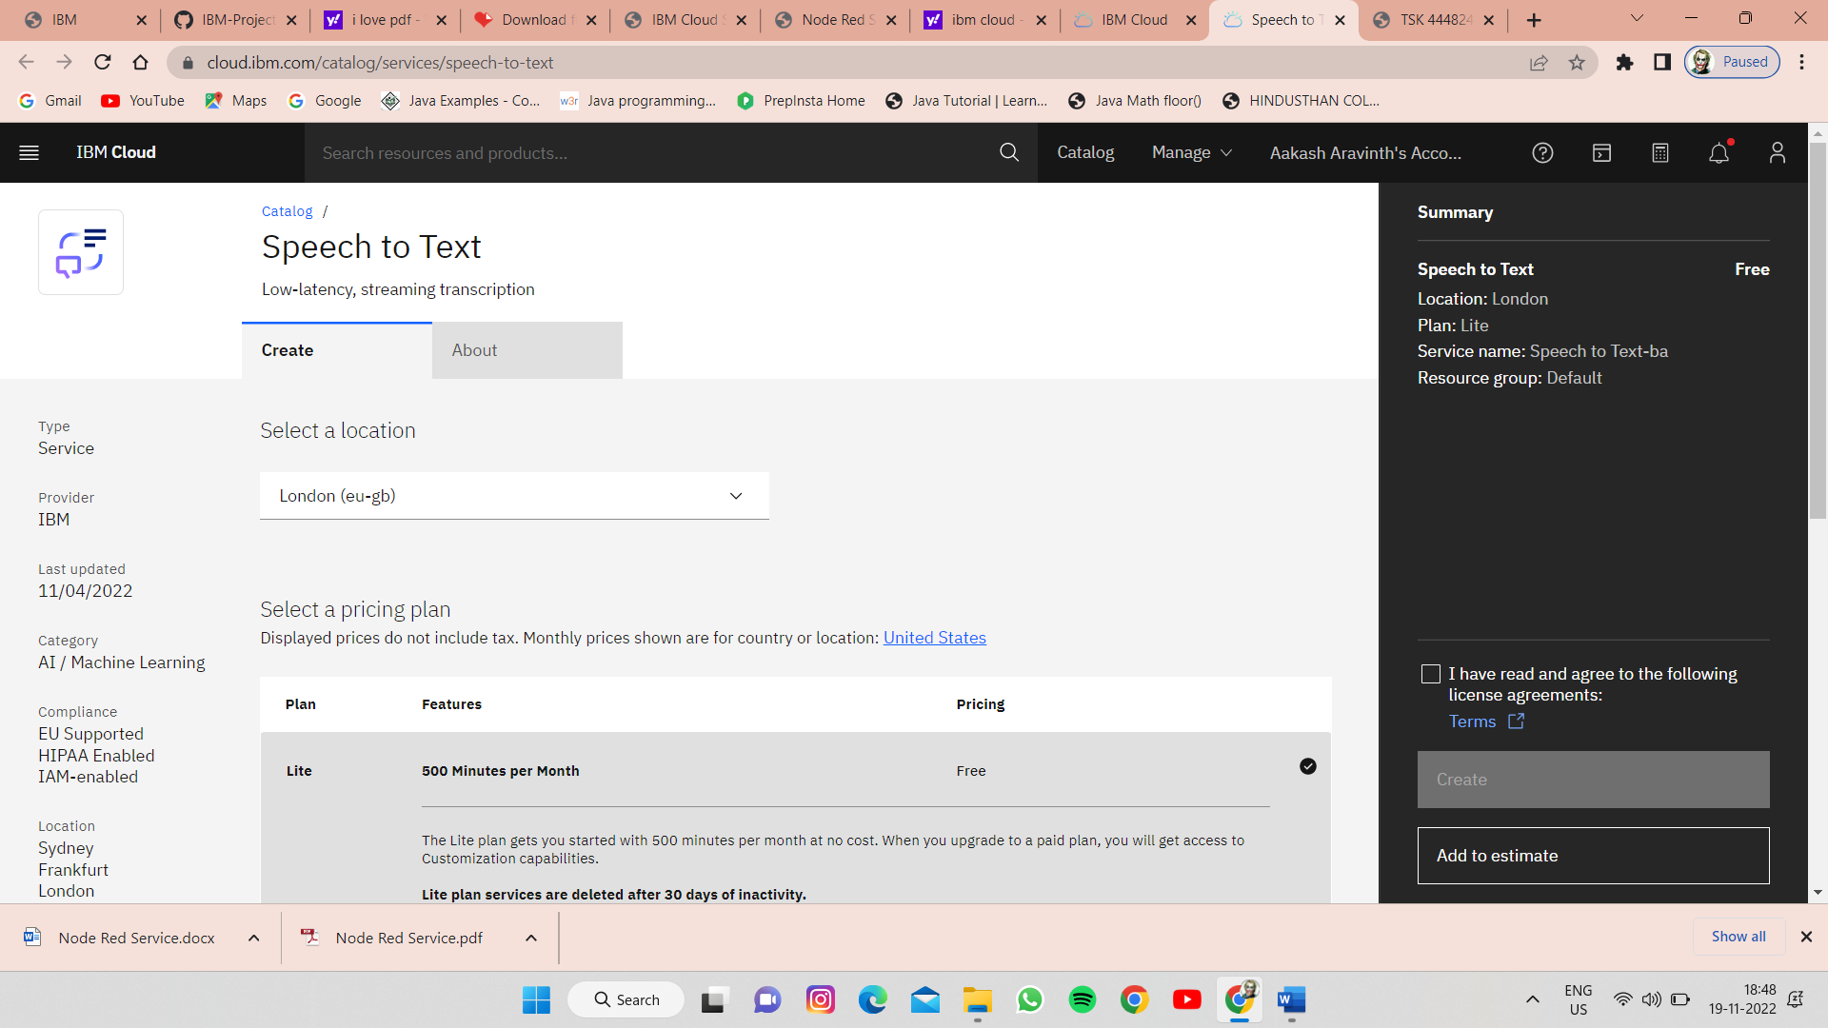

**STATUS :** ACTIVE

Execution & Test Run of Program to Access TTS:

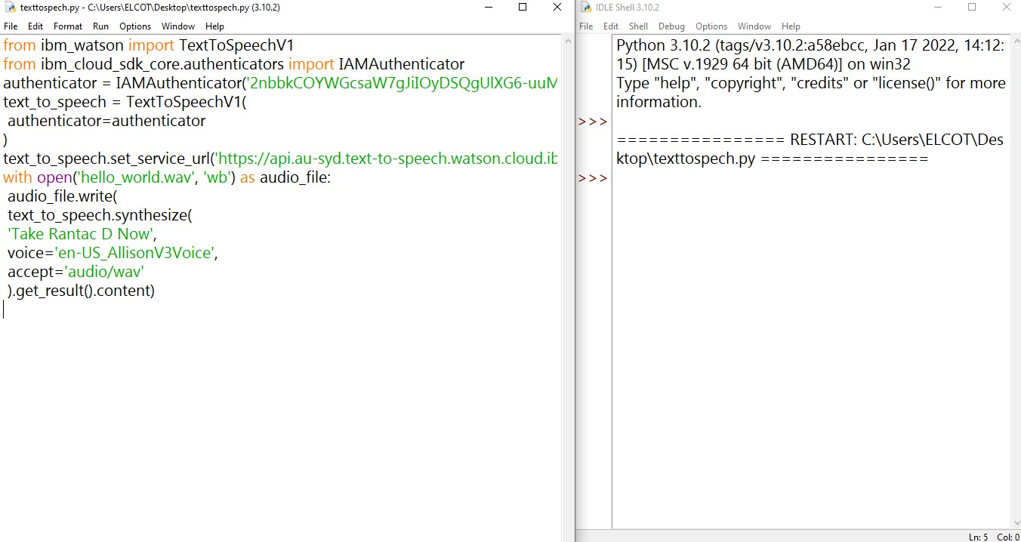

**RESULT :** SUCCESSFULLY CREATED